**Model Description**

We constructed three models to predict 14 actions respectively, which are respeck model (the model is only trained with respeck data), thingy model (the model is only trained with thingy data) and all model (the model is trained with respeck data and thingy data).

Using the data <https://github.com/specknet/pdiot-data/blob/master/2022/Respeck_recordings_clean.csv> and <https://github.com/specknet/pdiot-data/blob/master/2022/Thingy_recordings_clean.csv> to test the models.

For the Respeck model

|  |  |  |  |  |
| --- | --- | --- | --- | --- |
|  | precision | recall | f1-score | support |
|  |  |  |  |  |
| Climbing stairs | 0.58 | 0.47 | 0.52 | 2747 |
| Descending stairs | 0.43 | 0.55 | 0.48 | 2823 |
| Desk work | 0.31 | 0.33 | 0.32 | 3309 |
| Lying down left | 0.69 | 0.78 | 0.73 | 3315 |
| Lying down on back | 0.63 | 0.75 | 0.69 | 3331 |
| Lying down on stomach | 0.76 | 0.6 | 0.67 | 3345 |
| Lying down right | 0.79 | 0.82 | 0.8 | 3306 |
| Movement | 0.58 | 0.76 | 0.66 | 3317 |
| Running | 0.71 | 0.94 | 0.81 | 3232 |
| Sitting | 0.26 | 0.19 | 0.22 | 3293 |
| Sitting bent backward | 0.62 | 0.59 | 0.61 | 3294 |
| Sitting bent forward | 0.74 | 0.45 | 0.56 | 3296 |
| Standing | 0.46 | 0.5 | 0.48 | 3299 |
| Walking at normal speed | 0.67 | 0.47 | 0.55 | 3240 |
|  |  |  |  |  |
| accuracy |  |  | 0.59 | 45147 |
| macro avg | 0.59 | 0.59 | 0.58 | 45147 |
| weighted avg | 0.59 | 0.59 | 0.58 | 45147 |

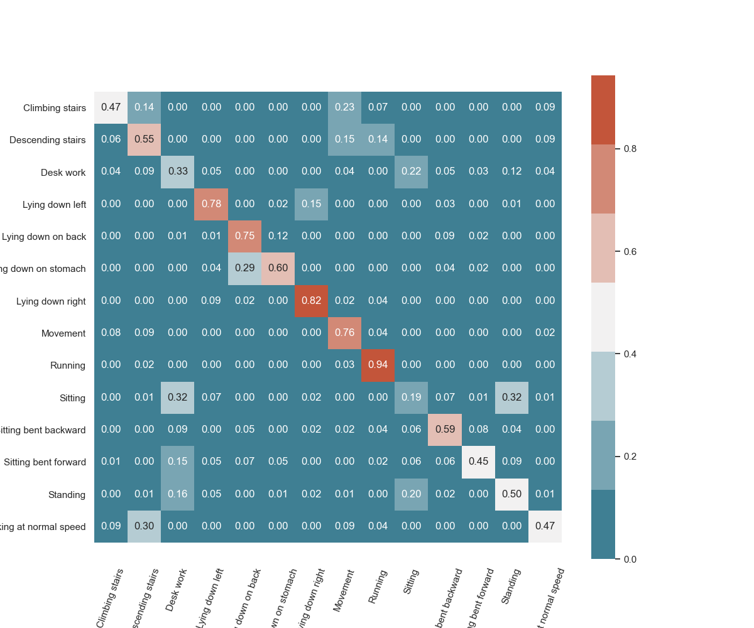

For the Thingy model

|  |  |  |  |  |
| --- | --- | --- | --- | --- |
|  | precision | recall | f1-score | support |
|  |  |  |  |  |
| Climbing stairs | 0.8 | 0.59 | 0.68 | 2791 |
| Descending stairs | 0.49 | 0.42 | 0.45 | 2703 |
| Desk work | 0.18 | 0.14 | 0.16 | 3281 |
| Lying down left | 0.64 | 0.56 | 0.6 | 3292 |
| Lying down on back | 0.26 | 0.35 | 0.3 | 3311 |
| Lying down on stomach | 0.7 | 0.69 | 0.7 | 3349 |
| Lying down right | 0.73 | 0.82 | 0.77 | 3258 |
| Movement | 0.53 | 0.69 | 0.6 | 3276 |
| Running | 0.78 | 0.98 | 0.87 | 3186 |
| Sitting | 0.19 | 0.11 | 0.14 | 3268 |
| Sitting bent backward | 0.26 | 0.2 | 0.22 | 3275 |
| Sitting bent forward | 0.2 | 0.16 | 0.18 | 3258 |
| Standing | 0.69 | 0.65 | 0.67 | 3272 |
| Walking at normal speed | 0.5 | 0.82 | 0.62 | 3111 |
|  |  |  |  |  |
| accuracy |  |  | 0.51 | 44631 |
| macro avg | 0.5 | 0.51 | 0.5 | 44631 |
| weighted avg | 0.49 | 0.51 | 0.49 | 44631 |

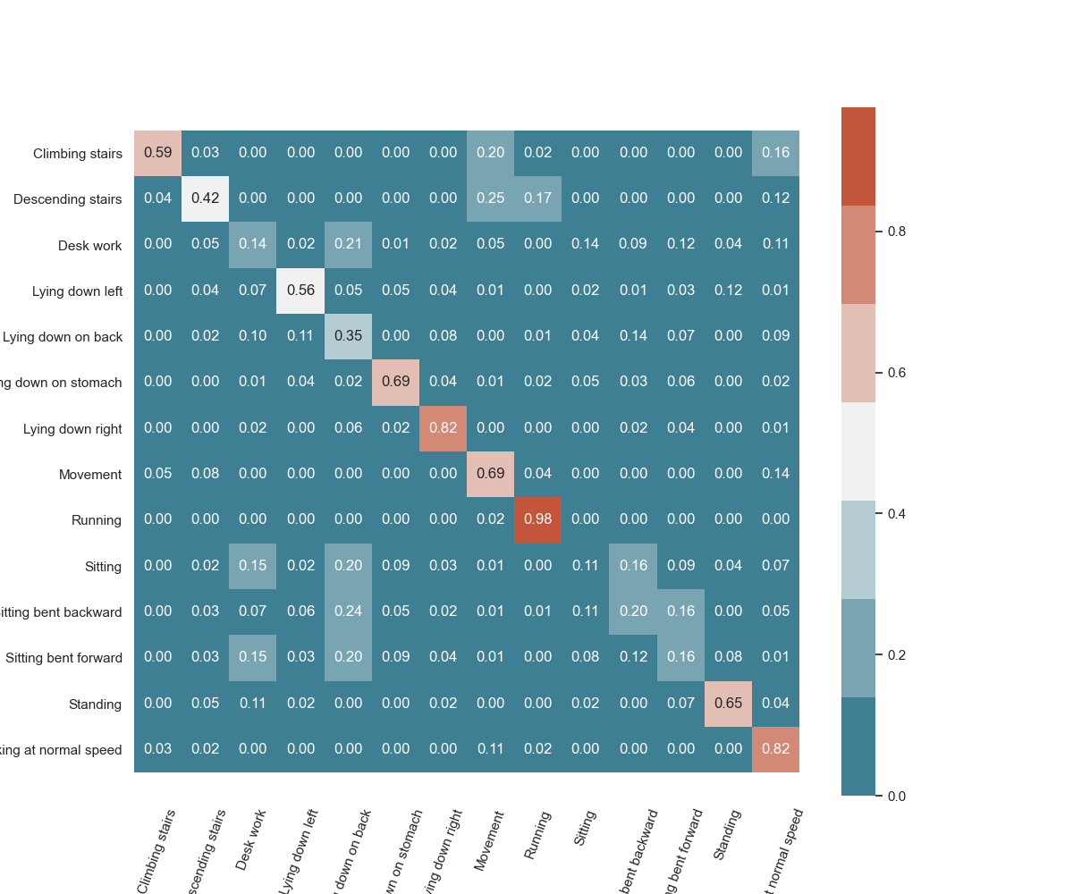

For all model

|  |  |  |  |  |
| --- | --- | --- | --- | --- |
|  | precision | recall | f1-score | support |
|  |  |  |  |  |
| Climbing stairs | 0.83 | 0.53 | 0.65 | 1556 |
| Descending stairs | 0.58 | 0.58 | 0.58 | 1554 |
| Desk work | 0.37 | 0.45 | 0.41 | 1908 |
| Lying down left | 0.69 | 0.62 | 0.65 | 1905 |
| Lying down on back | 0.55 | 0.8 | 0.65 | 1901 |
| Lying down on stomach | 0.84 | 0.82 | 0.83 | 1899 |
| Lying down right | 0.85 | 0.8 | 0.82 | 1900 |
| Movement | 0.6 | 0.9 | 0.72 | 1833 |
| Running | 0.79 | 0.96 | 0.87 | 1826 |
| Sitting | 0.54 | 0.26 | 0.35 | 1973 |
| Sitting bent backward | 0.77 | 0.59 | 0.67 | 1907 |
| Sitting bent forward | 0.51 | 0.54 | 0.52 | 1899 |
| Standing | 0.84 | 0.8 | 0.82 | 1909 |
| Walking at normal speed | 0.77 | 0.68 | 0.72 | 1901 |
|  |  |  |  |  |
| accuracy |  |  | 0.67 | 25871 |
| macro avg | 0.68 | 0.67 | 0.66 | 25871 |
| weighted avg | 0.68 | 0.67 | 0.66 | 25871 |

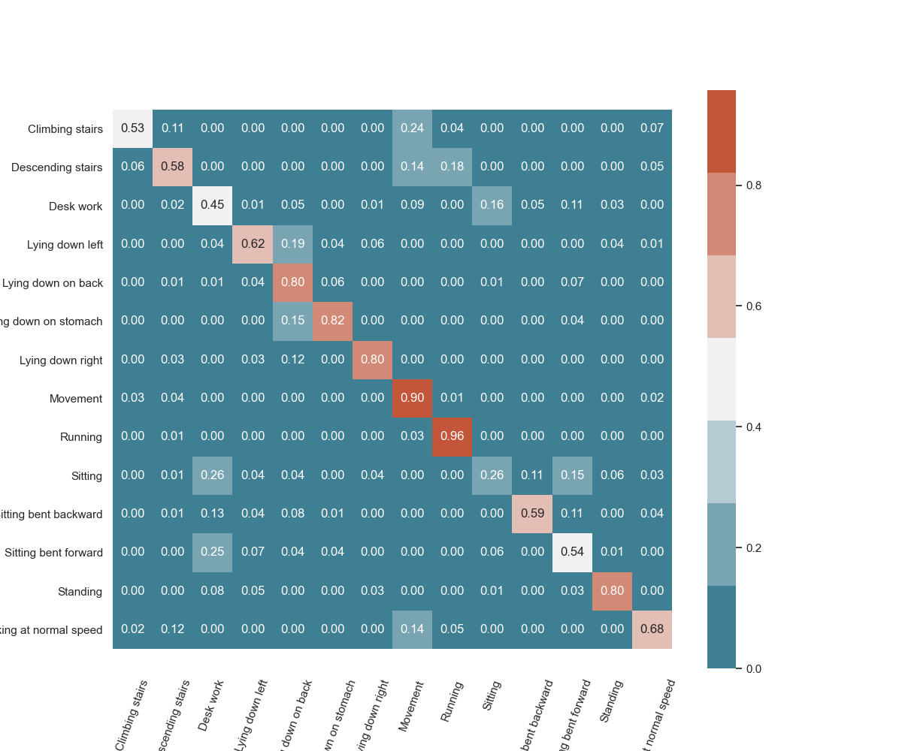

We can see that our model can accurately classify a large part of human actions. Different models produce high classification errors for some different actions. For instance, respeck mistakenly classifes sitting as desk work or standing, and classifies standing as sitting. Thingy performs poorly in action recognition related to sitting. The accuracy of the All model is better than both, but it is easy to misjudge the movement.

In LOSOXV, Our actual test results are basically the same as those displayed by the confusion matrices. But since our app counts predictions over time to make a final prediction and provides the two most likely actions, it always predicts the correct action.

Our model is trained using all the data under this folder(<https://github.com/specknet/pdiot-data/tree/master/2022>).

Running statement for the evaluate_models.py (

py ./evaluate_models.py --model_path=./respeck_model.tflite --respeck_file=Respeck_recordings_clean.csv

py ./evaluate_models.py --model_path=./thingy_model.tflite --thingy_file=Thingy_recordings_clean.csv

py ./evaluate_models.py --model_path=./all_model.tflite --thingy_file=Thingy_recordings_clean.csv --respeck_file=Respeck_recordings_clean.csv